Preparation for Worship:
“I will praise God’s name in song
and glorify him with thanksgiving.” (Psalm 69:30, NIV).
May God bless you as you praise and thank him today.
*Please stand as you are able Bold Items read in unison
GATHERING We come together to worship God
Welcome and Announcements
Invocation/Call to Worship: For I will pour water on the thirsty land, and streams on the dry ground; I will pour out my Spirit on your offspring, and my blessing on your descendants. (Isaiah 44:3)
Opening Prayer
* Opening Hymn – Joyful, Joyful We Adore Thee . . . . . . . . . . . . . . . . . . . Red #197
Confession of Sin: Almighty God, our Maker and Redeemer, we poor sinners confess to You that we are by nature sinful and unclean, and that we have sinned against You in thought, word, and deed. Therefore, we flee for refuge to Your infinite mercy and ask You for Christ’s sake, grant us forgiveness of all our sins, and by Your Holy Spirit increase in us true knowledge of You and of Your will and true obedience to Your Word, to the end that by Your grace we may come to eternal life, through Jesus Christ, our Lord. Amen.
Response:(sung, #129, v.2) Speak Thy pard’ning grace to me, Set the burdened sinner free; Lead me to the Lamb of God; Wash me in His precious blood.
Declaration of Grace
Prayers of the Church (P: Lord in Your mercy C: Hear our prayer.)
WORD We seek guidance from God’s Word
Jeremiah 28:5-9 Old Testament
Psalm 119:153-160 Responsive Reading
Romans 7:1-13 Epistle Lesson
* Confession of Faith (Apostles’ Creed): I believe in God, the Father Almighty, Maker of heaven and earth; And in Jesus Christ, His only Son, our Lord; Who was conceived by the Holy Spirit; born of the virgin Mary; suffered under Pontius Pilate; was crucified, dead and buried; He descended into hell; the third day He rose again from the dead; He ascended into heaven and is seated on the right hand of God the Father Almighty, from where He shall come to judge the living and the dead. I believe in the Holy Spirit; the Holy Christian Church; the communion of saints; the forgiveness of sins; the resurrection of the body; and the life everlasting. Amen.
* Gloria Patri: (sung, p. 4) Glory be to the Father, and to the Son, and to the Holy Ghost; As it was in the beginning, is now, and ever shall be, world without end. Amen, Amen.
*Offertory (sung, p. 33 for melody) Create in me a clean heart, O God, and renew a right spirit within me. Cast me not away from your presence: and take not Your Holy Spirit from me. Restore unto me the joy of Your salvation: and uphold me with Your free Spirit.
Children’s Sermon
Hymn – O for a Closer Walk with God . . . . . . . . . . . . . . . . . . . . . . . . . Red #466
* Sermon Text: Gospel - Matthew 10:34-42
Sermon – Kingdom Priorities . . . . . . . . Pastor Barry
SENDING We go out to live in & share God’s Word
* Closing Hymn – Jesus, Jesus, Only Jesus . . . . . . . . . . . . . . . . . . . . . Red #216
* Lord’s Prayer: Our Father, who art in heaven; hallowed be Thy name; Thy kingdom come; Thy will be done on earth, as it is in heaven; give us this day our daily bread; and forgive us our trespasses, as we forgive those who trespass against us; and lead us not into temptation; but deliver us from evil; for Thine is the kingdom, and the power, and the glory, forever and ever. Amen.
* Benediction & Doxology: (sung, p. 24 for melody) Praise God, from whom all blessings flow; Praise Him, all creatures here below; Praise Him
above, ye heavenly host: Praise Father, Son, and Holy Ghost. Amen.
* Dismissal L: Go in Peace, and Serve the Lord. C: Thanks be to God.

Called Friends by Christ
According to John’s Gospel, Jesus said to those who knew him best, “No longer do I call you servants, for the servant does not know what his master is doing; but I have called you friends. … You did not choose me, but I chose you and appointed you that you should go and bear fruit” (John 15:15–16, ESV).
The depth of Christ’s friendship is seen in his willingness to give his life for his friends — and for us as well. “Greater love has no one than this, that someone lay down his life for his friends. You are my friends if you do what I command you” (John 15:13–14, ESV).
By obeying our Lord and showing love to others, we demonstrate our friendship with Christ. Friendship with Christ and with one another is, according to the Christian layman and president Woodrow Wilson, “the only cement that will hold the world together.”

This Week in the Parish - June 28 – July 5
SUNDAY 9:00 am First American Worship with Holy Communion
10:45 am Hope Worship with Holy Communion
Rejoicing in your presence & gifts – June 21, 2026
First American: General—$1460.75. Benevolence—$45. Noisy Offering for Tammy Ziegler—$113.10. Budget per Sun—$2068.
Welcome friends! We’re here today because God has searched for and found us, as he did Adam and Eve, hiding in the Garden of Eden. Our Maker loves us and offers us lavish forgiveness. Please be sure to introduce yourself and sign our guest register as you leave.
Prayer in our corporate worship service is very important. To maintain a current prayer list, requests for non-members will be in the bulletin for three weeks. For additional time, please send an update to Pastor Barry. New additions will be underlined, and those scheduled to come off will be in italics.
Health Needs of our Members: Russ Dozark. Allan Hale. Dawsyn Johnston. Robert Kurtz. Sue Neumeister. Tammy Ziegler. Glendora Zeitner.
Health Needs: Donna Soulek (former Hope member). Jeanette Tiede (sister of Lila Fechner). Rachel (mother of Trista Friman).
Sympathy: Prayers of comfort for the family & friends of Loren Buchholz (Tripp community).
Birthdays: 30 David Mogck, Matthew Schempp. 1 Jamie Ziegler. 3 Adam Brock, Cody Dozark, Chancy Jensen.
Anniversaries: 22 Andrew & Liza Hanson. 28 Del & Susan Neumeister.
AFLC Churches: Faith Lutheran, Durant, OK; Rose Free Lutheran, Roseau, MN; Zion Lutheran, Valley City, ND. Mission: Tripp & Delmont Fire Department
Prayer for military personnel:
Andrew Hanson: Hope member. Stationed in Kentucky; Army.
Austin Lien: nephew of Glenn & Tammy Ziegler. Stationed in Washington; Navy
Dalton Fischer: brother of Malorie Walz. Stationed in Germany. National Guard.

Quilt Show: On July 3rd, in conjunction with the All-School Reunion, there will be a quilt show at First American from noon – 6 pm. Quilted items have been donated by Tripp-Delmont alumni and for $1/entry or $5/6 entries, you can get your name in a drawing to win the items. All proceeds go to the Tripp Action Group.

Tripp-Delmont Parish + Association of Free Lutheran Churches
Pastor Barry Nelson

First American Lutheran Church Hope Lutheran Church
300 S. Carpenter PO Box 459 200 S. Wilson PO Box 127
Tripp, SD 57376 Delmont, SD 57330
Parish office: 935-6941 Parsonage: 935-6942
Parish Email: firsthope@santel.net Parish Website: www.FAHope.org
Today’s Readings
June 28, 2026 Fifth Sunday after Pentecost
Old Testament Jeremiah 28:5-9
⁵ Then the prophet Jeremiah replied to the prophet Hananiah before the priests and all the people who were standing in the house of the Lord. ⁶ He said, “Amen! May the Lord do so! May the Lord fulfill the words you have prophesied by bringing the articles of the Lord’s house and all the exiles back to this place from Babylon. ⁷ Nevertheless, listen to what I have to say in your hearing and in the hearing of all the people: ⁸ From early times the prophets who preceded you and me have prophesied war, disaster and plague against many countries and great kingdoms. ⁹ But the prophet who prophesies peace will be recognized as one truly sent by the Lord only if his prediction comes true.”
Psalm 119:153-160
¹⁵³ Look on my suffering and deliver me,
for I have not forgotten your law.
¹⁵⁴ Defend my cause and redeem me;
preserve my life according to your promise.
¹⁵⁵ Salvation is far from the wicked,
for they do not seek out your decrees.
¹⁵⁶ Your compassion, Lord, is great;
preserve my life according to your laws.
¹⁵⁷ Many are the foes who persecute me,
but I have not turned from your statutes.
¹⁵⁸ I look on the faithless with loathing,
for they do not obey your word.
¹⁵⁹ See how I love your precepts;
preserve my life, Lord, in accordance with your love.
¹⁶⁰ All your words are true; all your righteous laws are eternal.
Epistle Romans 7:1-13
Do you not know, brothers and sisters—for I am speaking to those who know the law—that the law has authority over someone only as long as that person lives? ² For example, by law a married woman is bound to her husband as long as he is alive, but if her husband dies, she is released from the law that binds her to him. ³ So then, if she has sexual relations with another man while her husband is still alive, she is called an adulteress. But if her husband dies, she is released from that law and is not an adulteress if she marries another man. ⁴ So, my brothers and sisters, you also died to the law through the body of Christ, that you might belong to another, to him who was raised from the dead, in order that we might bear fruit for God. ⁵ For when we were in the realm of the flesh, the sinful passions aroused by the law were at work in us, so that we bore fruit for death. ⁶ But now, by dying to what once bound us, we have been released from the law so that we serve in the new way of the Spirit, and not in the old way of the written code. ⁷ What shall we say, then? Is the law sinful? Certainly not! Nevertheless, I would not have known what sin was had it not been for the law. For I would not have known what coveting really was if the law had not said, “You shall not covet.” ⁸ But sin, seizing the opportunity afforded by the commandment, produced in me every kind of coveting. For apart from the law, sin was dead. ⁹ Once I was alive apart from the law; but when the commandment came, sin sprang to life and I died. ¹⁰ I found that the very commandment that was intended to bring life actually brought death. ¹¹ For sin, seizing the opportunity afforded by the commandment, deceived me, and through the commandment put me to death. ¹² So then, the law is holy, and the commandment is holy, righteous and good. ¹³ Did that which is good, then, become death to me? By no means! Nevertheless, in order that sin might be recognized as sin, it used what is good to bring about my death, so that through the commandment sin might become utterly sinful.
Reader: This is the Word of the Lord. C: Thanks be to God.
Gospel Matthew 10:34-42
³⁴ “Do not suppose that I have come to bring peace to the earth. I did not come to bring peace, but a sword. ³⁵ For I have come to turn “‘a man against his father, a daughter against her mother, a daughter-in-law against her mother-in-law—³⁶ a man’s enemies will be the members of his own household.’ ³⁷ “Anyone who loves their father or mother more than me is not worthy of me; anyone who loves their son or daughter more than me is not worthy of me. ³⁸ Whoever does not take up their cross and follow me is not worthy of me. ³⁹ Whoever finds their life will lose it, and whoever loses their life for my sake will find it. ⁴⁰ “Anyone who welcomes you welcomes me, and anyone who welcomes me welcomes the one who sent me. ⁴¹ Whoever welcomes a prophet as a prophet will receive a prophet’s reward, and whoever welcomes a righteous person as a righteous person will receive a righteous person’s reward. ⁴² And if anyone gives even a cup of cold water to one of these little ones who is my disciple, truly I tell you, that person will certainly not lose their reward.”
Lessons – July 5, 2026 OT – Zechariah 9:9-12 Psalm 145:1-14
Epistle – Romans 15:8-13 Gospel – Matthew 11:25-30

Matthew 10:34-42
“Kingdom Priorities” June 28, 2026

1. Serve Jesus Above Family
2. Serve Jesus Above Self
3. Serving Jesus by Serving One Another
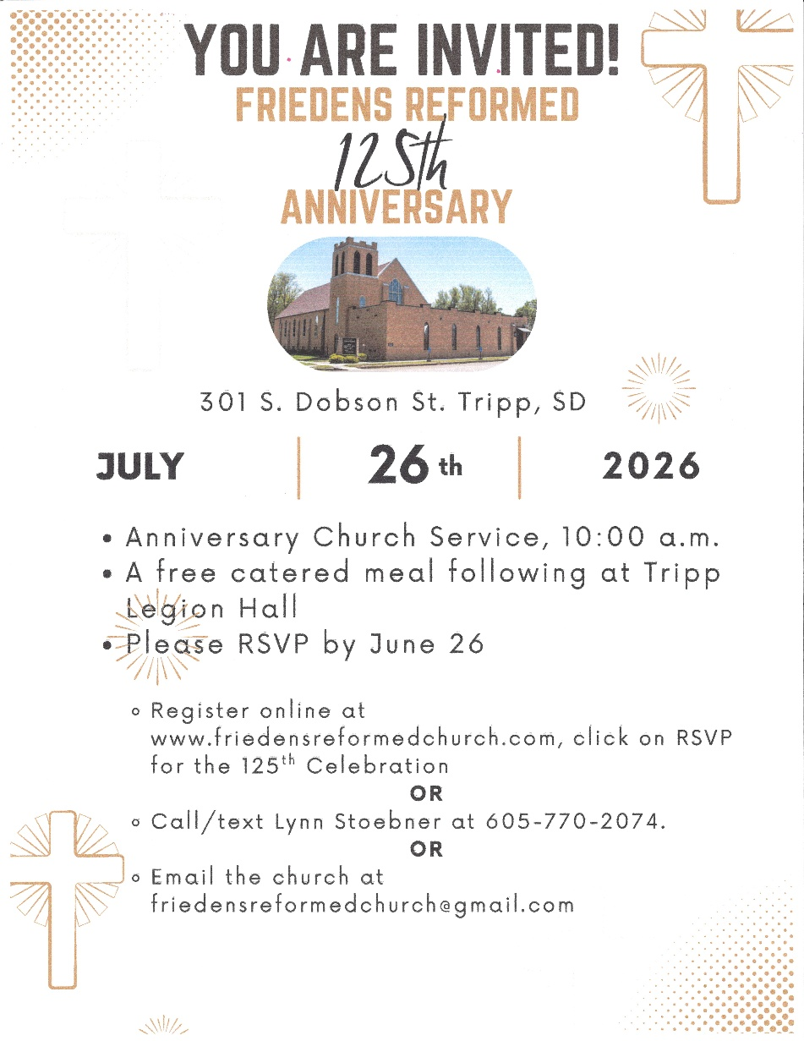
Church Directory Committee: The council of First American is interested in putting together a committee to oversee the creation of an updated church directory. Our last directory was printed in 2013, and we have had a lot of changes since then! If you are interested in serving, please contact Pastor Barry.
The Tripp-Delmont Parent Teacher Children Organization will be having a free will donation fundraiser breakfast on Sunday, July 5th at the Tripp Fire Hall from 9am – 1 pm.

